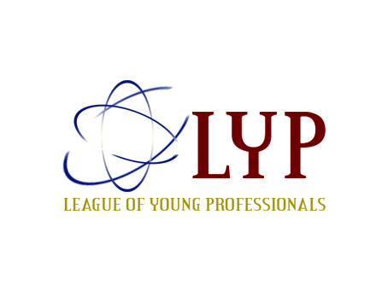
The League of Young Professionals (LYP) - Kenya
P.O. Box 16924- 00100 Nairobi I Email: info@ypkenya.org.
Website: www.ypkenya.org
2016 February Monthly Talk
Topic: Start Right, Grow Right.
Date & Venue: Thursday, 25th February at KICC, Tin Tin

PARTICIPANT PARTICULARS (BLOCK LETTERS)

- Names………………………………… …………………………………………………..

- Occupation…………………………………………Employer…………………………...

- Email……………………………………..Tel No:………………………………...

- MPESA Ref. No …………………… Amount Sent…………………….

